**E-channeling System**

**Kaveen Charuka**

1. **What is the major problem being solved?**

* Look up a doctor in the user area who is available, then book an appointment.

1. **What are the other problems being solved?**

* User can get medication delivered to users’ doorstep.
* When uploading, users may check their laboratory reports.
* The user can book a PCR test.
* The user could locate doctors nearby.
* The user can easily book an appointment for get driving license medical
* The mother care, childcare, elder care, personal treatment, and mind drone facilities are all included in the medical packages provided by E-Channeling.

1. **Who are the users of the system?**

* Doctors
* Patients
* Admin
* Delivery guys

1. **What benefits each user gets**

* Doctors – Save doctors time, more patients can be treated
* Patients - it is possible to connect to the doctor online, easy to book an appointment, patient can get medication delivered to users’ doorstep.
* Admin - Ability to work easily due to user-friendly
* Delivery guys – using the website map, drivers can locate the delivery location with ease.

1. **What are the other alternative similar systems available and do a comparison?**

* **Nawaloka Hospital website -** [**https://www.nawaloka.com/**](https://www.nawaloka.com/)

while comparing the websites for the e-channel and the Nawaloka hospital. The Echannelling website is in great condition. because the Nawaloka Hospital's website mainly contains information on the hospital. However, we can find any doctor utilizing the Echanneling system, communicate with them, and schedule an appointment.

1. **Understand the process of channeling a doctor and briefly describe in words and in a graphical way.**

* Go to E-channeling.com Website
* Login/Sign up to website using phone number
* Under Doctor Channeling Section Select hospital type from drop down – Doctors, Specialization, location, and appointment date.
* Doctor Name
* Click Search Button.
* Website will navigate user into new page where user can see the availability of the doctor.
* Clicking available button user navigate to form
* User must fill the appointment Form (If user already logged then data will be filled automatically)
* After filling this form then user must accept terms & conditions
* Then click pay button
* System will pop-up a select payment method window.
* After selecting payment method click Proceed to Payment button.
* Then system will navigate user into payment gateway page.
* After making the payment system will show the success message then send the appointment details to user mobile number and email.

1. **Describe each user interface used in the process (workflow) of channeling the doctor (Hint: Use screen clipping feature in MS Word)**

Home page of channeling website

* Website will navigate user into new page where user can see the availability of the doctor.

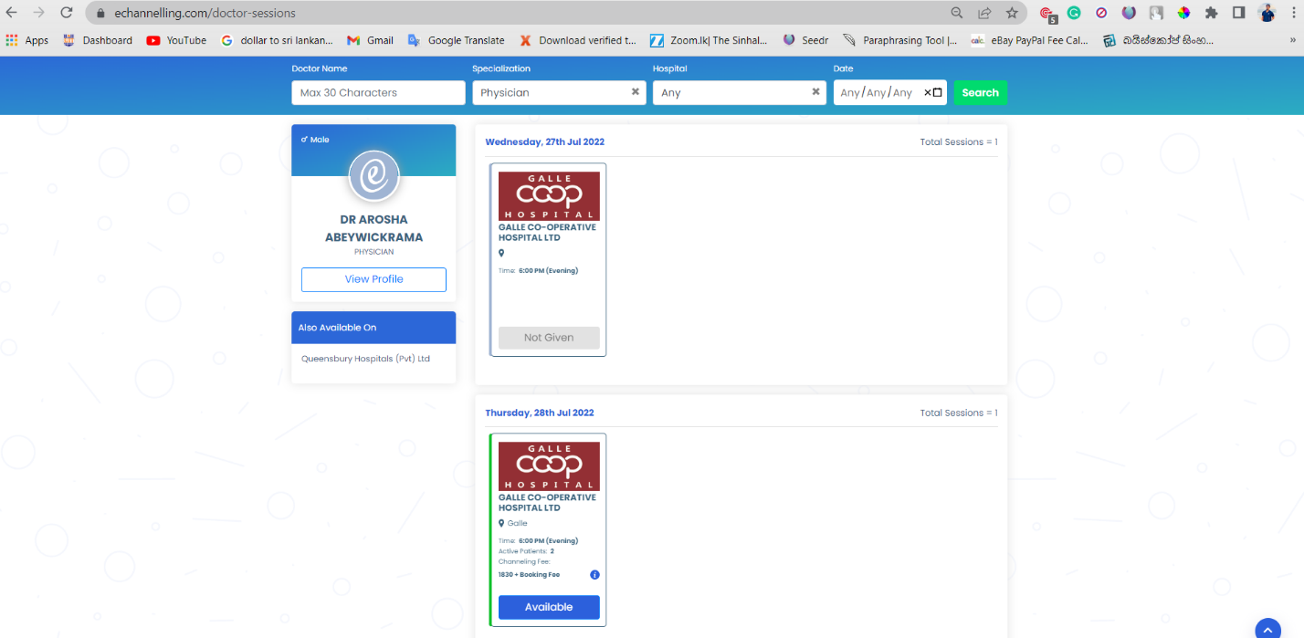

* Clicking available button user navigate to form

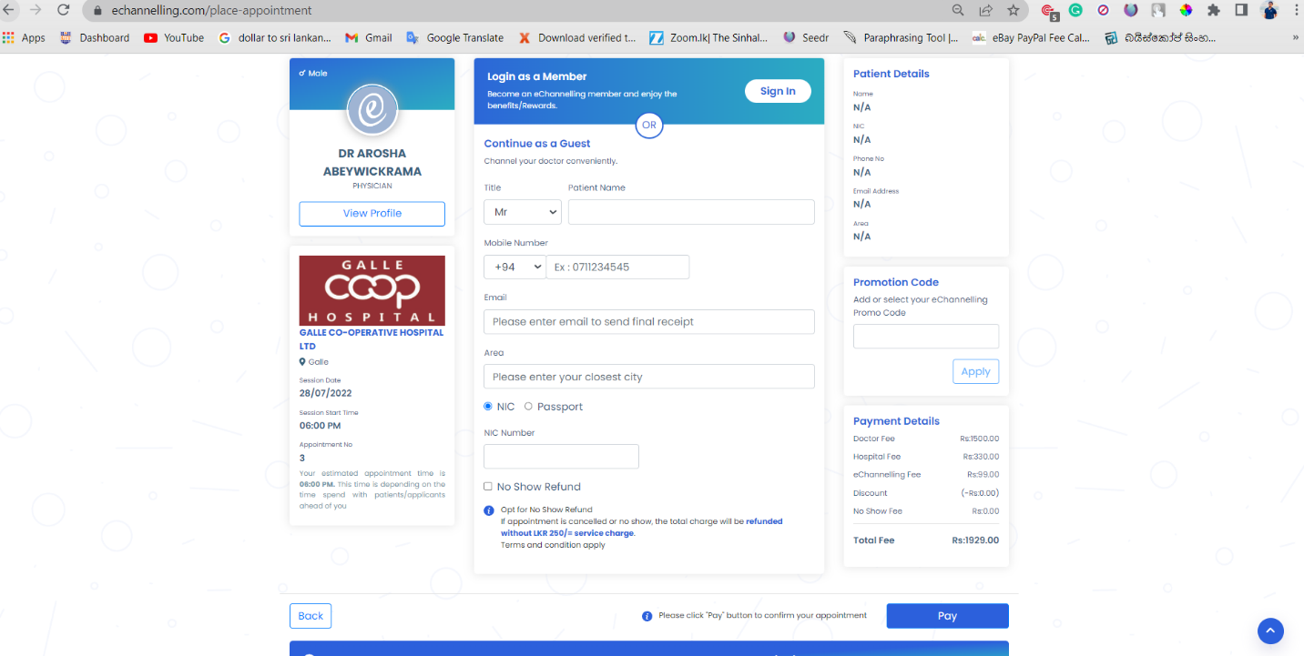

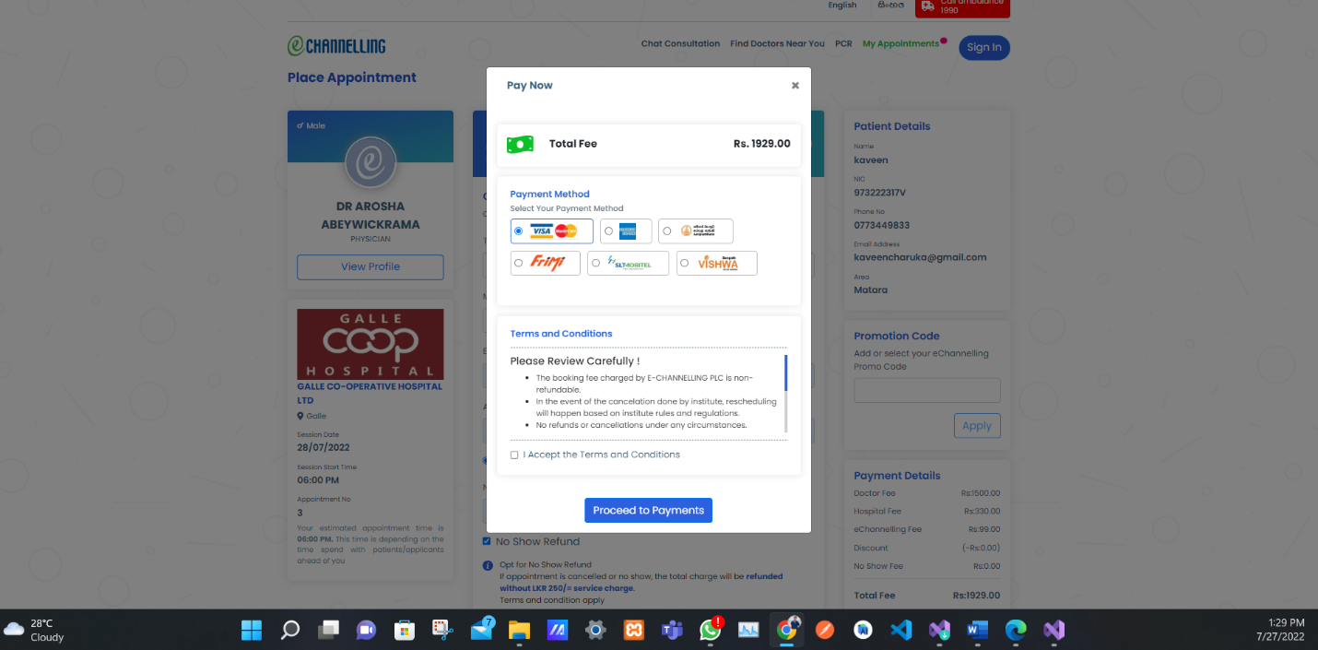

1. **What is the type of software solution (desktop, client-server, web)**

Web application and mobile application

1. **What should be the data stored in the database**

* AppointmentID
* Patient mobile Number
* Patient Name
* Patient email
* Patient NIC and passport
* Doctor name
* Appointment time and date
* Payment amount

1. **Try to draw a technical diagram to illustrate the communication from browser network-server-database.**

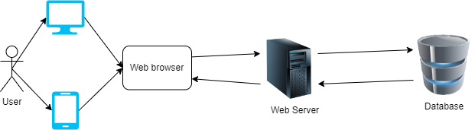

1. **Do you think that the system has an administrative user? If so mention 3 tasks.**

Yes,

* Adding doctors
* Adding hospitals
* Adding employee (delivery)
* Maintaining system
* Maintain appointment details
* Users maintain

1. **Considering total scenario, what are the processes and activities you cannot achieve through the system (that user should do manually)**

We can’t verify doctors are real or not

We can’t track our product delivery man

1. **Suggest some ways of automating the activities that you mention in no. 12**

I suggest implementing to the map track the delivery man